

**Report 3**

**Redesign of The Center for Information Assurance Website**

November 28th, 2016

**CPIS Consulting**

**CPIS Consulting**

**College of Business Administration**

**3801 Temple Ave. Pomona CA, 91768**

**THE CENTER FOR INFORMATION ASSURANCE**

**Prepared For:**

Ronald E. Pike, Ph.D.

College of Business Administration

3801 Temple Ave. Pomona CA, 91768

Email: rpike@cpp.edu

Phone: 909-869-5284

**Prepared By:**

CPIS Consulting

Christopher Valades,

**Project Manager**

Arthur Santos,

**Documentation**

Carmen Ng and

Jack Guo and

Justin Razon,

**Developers**

**Table of Contents**

1. Introduction4

2. Project Management5

2.1 Objectives5

2.2 Achievements5

3. Overview6

3.1 Client Requests6

3.2 Interviewing Clubs / Professors6

3.3 Site Pages and Navigation7

3.3.1 About8

3.3.2 Academics9

3.3.3 Projects10

3.3.4 Research11

3.3.5 Events11

3.3.6 Contact11

3.4 Club Information

3.4.1 CSS12

3.4.2 MISSA 13

3.4.3 IWDSA 14

3.4.4 IEEE15

3.4.5 FAST16

3.4.5 SWIFT17

3.5 Researching and Creating Wireframe 18

3.6 Style and Design19

4. Challenges and Obstacles21

5. Time Overview23

5.1 GANTT Chart23

6. UX Testing25

7. Measures of Success28

8. Project Proposal28

9. Project README for Next Group29



**1. Introduction**

CPIS Consulting is a firm founded by senior college students at Cal Poly Pomona. CPISC combines innovative solutions for client requests and presents it in a modern and functional fashion. We focus on listening very closely to the client’s visions and using that information to create a product that will be revolve around design, functionality, and effectiveness. We deliver the highest quality work by maintaining strong communication with the client, effective project management, and an alluring product design.

CPIS Consulting is privileged to submit the proposal to Ronald E. Pike for the redesign of “The Center for Information Assurance” website. We look forward to an opportunity to work with the clubs, organizations, and professors on this exciting project.

From what we gathered in our initial meeting with Dr. Ronald E. Pike, the university seeks to improve and modernize the existing website for The Center for Information Assurance. The objective is to create a focal point for cyber defense activities and for information assurance activities. We would like to maintain that focus, but also expand by doing the following:

* Making The Center of Information Assurance uniform with the Center for Applied Business Information Technology website. The site should have a direct link that leads to the Mitch C. Hill site. It must also be communicated with the developers of their website which links back to The Center of Information Assurance website.
* Create a centralized location for related cyber security clubs to share resources, success stories, research, and previous projects. This site will also work as a venue where clubs and organizations are aided in receiving funding from sponsor companies.
* If a company is seeking students or personnel to complete a project for their organization, The Center of Information Assurance would be the ideal location to demonstrate what Cal Poly Pomona has to offer.
* The site will also contain information on classes/curriculum at Cal Poly Pomona, informing visitors how specific classes can help achieve success in the cybersecurity field.

The designated point of contact for all communications regarding this proposal is Christopher Valades. He may be reached at csvalades@cpp.edu.

**2. Project Management**

**2.1 Objectives**

The following main objectives are targeted by CPIS Consulting:

* **Obtain Credentials** → Need information about CAE accreditation as well, would help to see how the main website presented it.
* **Develop a Working Prototype** → Have a working product for our in-class demonstration.
* **Complete Collecting Content**→ Conclude the interviews with the cyber security organizations and the school professors as well as retrieve content from client

**2.2 Achievements**

The following tasks have been achieved in line with the objectives outlined above:

* **Obtain Credentials**
  + Collected information from our client
  + Discussed obtaining a new domain and hosting service for the site
* **Working Prototype**
  + Researched templates and designs that work in line with the client’s requests.
  + Created a wireframe and mockups using various tools online + Adobe Photoshop.
  + Settled on color scheme and overall design layout
* **Complete Collecting Content**
  + Attempted to contact all of the clubs and professors for information.
  + Completed various interviews with Dr. Husain, Dr. Carlton, MISSA, and SWIFT.
  + Presented wireframe to Dr. Carlton for input on the direction of the website.

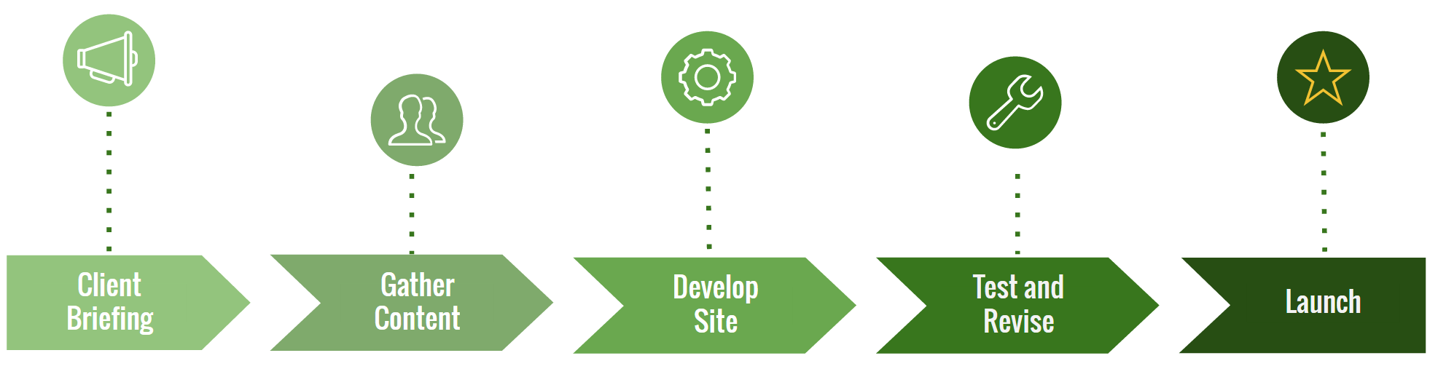

***Figure 1****: Completion Plan*

**3. Overview**

**3.1 Client Requirements**

* Create a central location to represent information assurance at Cal Poly Pomona.
* The client expressed an interest to have the site go hand-in-hand with the “Center for Applied Business Technology” website, also known as the Mitchell C. Hill website.
* Make the site cross interdisciplinary. The site should not focus solely on computer information systems, but should include other departments (i.e. computer science and electrical engineering).
* Have a location to showcase all the clubs and all their research, events, and accomplishments.
* Discussion as to what the main navigation bar should be and what the sub categories will be.
* Desire to have a curriculum section on the site and explain how they will align with student projects.
* Including a section on the site for competition information (i.e. upcoming events, why they are important, discuss different types of events, etc.)
* Credentials for the website and where they should be obtained from.
* New alternatives for the site name and abandoning the current name, “The Center for Information Assurance”.
* Obtaining content from the professors or clubs and organizations themselves. They will provide the content as they want represented.

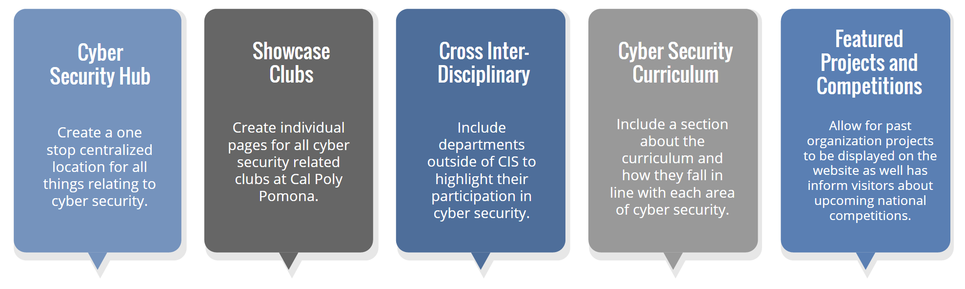

***Figure 2****: Objectives*

**3.2 Interviewing Clubs / Professors**

As part of our process to gather information about each respective organization and what their specialization is in, we decided to conduct interviews to learn more about them. We reached out to four of Cal Poly Pomona’s top CIS clubs (SWIFT, FAST, MISSA, and IWDSA) as well as other related organizations in other departments (IEEE and CSS). It was recommended by the client that we contact professors in the departments of Computer Information Systems, Computer Science, and Electrical Engineering.

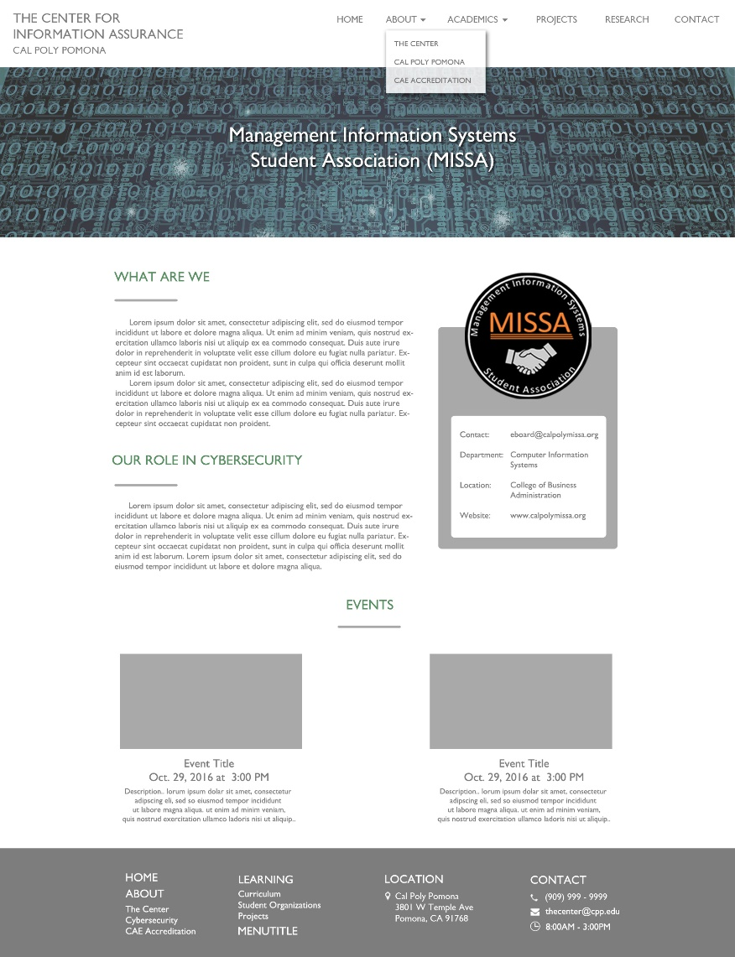As a team, we decided on 5 base questions to ask these organizations and professors in order to collect as much as possible about what they do and how they would like to be represented on The Center of Information Assurance website. Some of the information we were seeking was:

**Figure 3**: Club Page

* How cyber security plays a role in their club
* How they would like to be represented on the website
* If the club has been involved with TCFIA in the past
* What would they like shown on the site, or emphasized about their organization
* Any extra information about the site which could include topics, projects, images, etc.

To make sure we covered all the organizations at Cal Poly Pomona that are related to cyber security, we reached out to Dr. Mohammad I. Husain for his suggestions on which computer science clubs to include.

**3.3 Site Pages and Navigation**

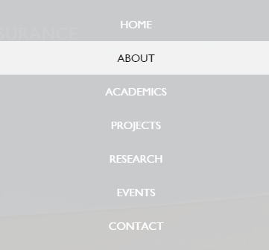After careful planning, we designed our site map so that we can determine the pages to be displayed on the navigation bar and the drop down menus. After discussing the navigation bar with our client during our second meeting, we decided on using Home, About, Academics, Projects, Research, Events, and Contact with sub-menus for each.

**Figure 4:** Navigation Menu in Condensed Form

**ABOUT**

**ABOUT > The Center**

This page gives a general overview description about what The Center for Information Assurance is and what visitors can expect to find while navigating the site.

**Mission Statement**

The Center for Information Assurance combines the College of Business and College of Science emphasis on strategic use of information technology, the CIS/CS learn-by-doing approach to using computers, and the MSBA emphasis on information systems audit to further the study of information Assurance and forensics

**Why do we do what we do?**

We are dedicated to serving the Cyber Security community through many different events, programs, workshops, competitions, and camps. Our main purpose is to further the advancement of Cyber Security throughout the nation. The Center for Information Assurance at Cal Poly Pomona is the focal point on campus for cyber security between the different majors on campus that serve a role in this field. It is a collaboration between the Computer Information Systems major in the College of Business, Computer Science major in the College of Science, and lastly Computer Engineering major in the College of Engineering. The ultimate goal is to create well trained and driven professionals within and outside of Cal Poly Pomona university. We are dedicated to serving the cybersecurity community through many different events, programs, competitions, and collaborations. We hope to create interest in the field for future university students and ultimately further the advancement of cybersecurity throughout the fast changing technological world.

**ABOUT > Our Faculty**

This page was designed to give Cal Poly Pomona’s faculty a short introduction for visitors to the site. This information was collected using the universities staff profiles.

**Dr. Ronald Pike**

Dr. Ronald Pike is the Executive Director for the Center for Information Assurance. Dr. Pike earned his Ph.D in Management Information Systems at the Washington State University and is an assistant professor at Cal Poly Pomona in the Department of Computer Information Systems teaching and researching topics in networking and network security.

**Dr. Mohhamad Husain**

Graduated with a PhD in Computer Science and Engineering from the University of Buffalo, Dr. Husain is a tenure-track assistant professor at Cal Poly Pomona under the Computer Science Department. His research includes topics, such as developing a holistic approach to lightweight data security in embedded cloud computing domain, but his broad interest is in the field of security and forensics. Dr. Husain leads the PolySec Lab on campus; to learn more, visit its web space (<http://www.cpp.edu/~polysec/>).

**Dr. Daniel Manson**

Dr. Dan Manson is the current Department Chair and professor in the Computer Information Systems department at Cal Poly Pomona. Dr. Manson teaches topics in Information Systems Auditing, Internet Security, and Computer Forensics for both undergraduate and graduate programs in Information Systems Auditing. He also led the effort for Cal Poly Pomona’s designation as a Nation Center of Academic Excellence in Information Assurance in 2005 and 2008. His research interests are based in security and information assurance.

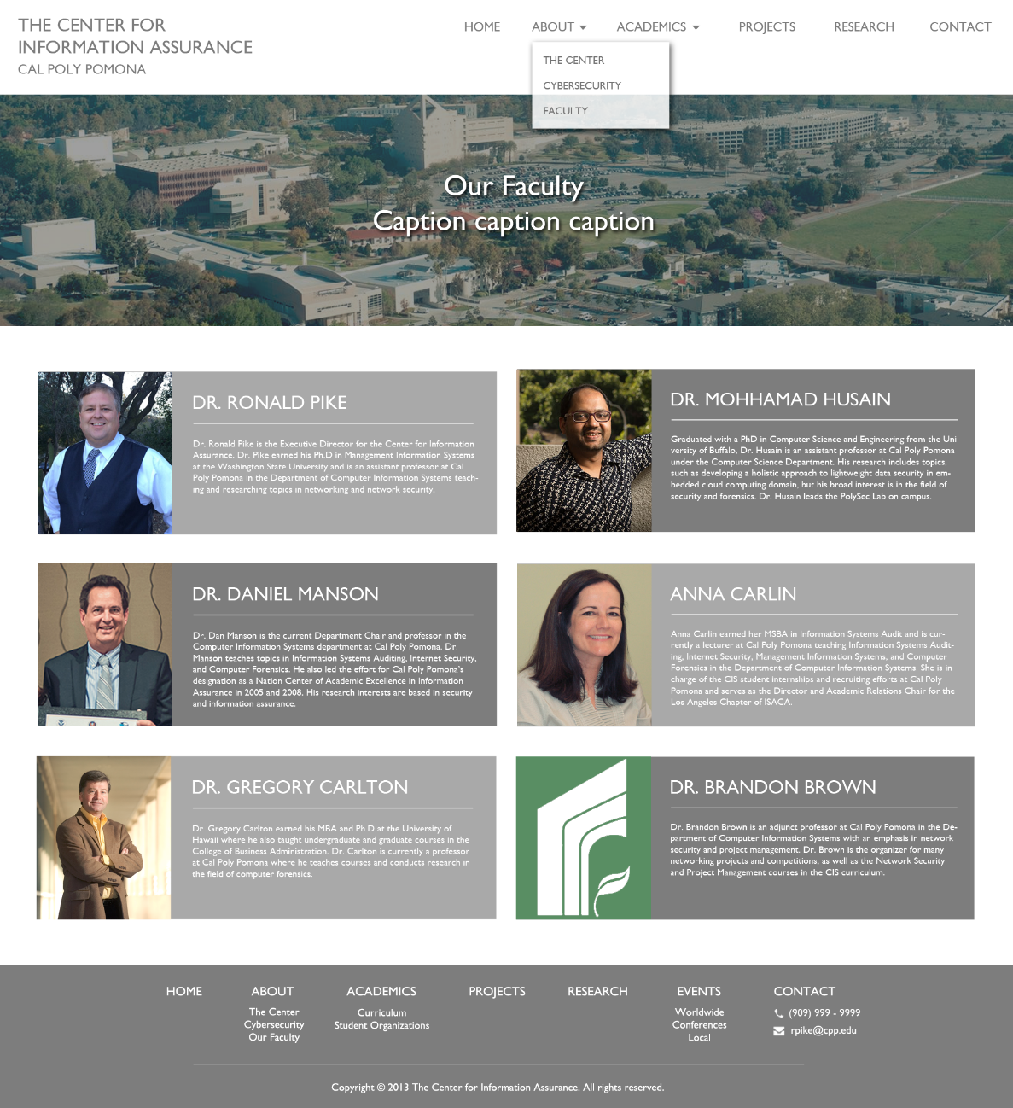

***Figure 5:*** *Faculty Page*

**Anna Carlin**

Anna Carlin earned her MSBA in Information Systems Audit and is currently a lecturer at Cal Poly Pomona teaching Information Systems Auditing, Internet Security, Management Information Systems, and Computer Forensics in the Department of Computer Information Systems. She is in charge of the CIS student internships and recruiting efforts at Cal Poly Pomona and serves as the Director and Academic Relations Chair for the Los Angeles Chapter of ISACA.

**Dr. Greg Carlton**

Dr. Gregory Carlton earned his MBA and Ph.D at the University of Hawaii where he also taught undergraduate and graduate courses in the College of Business Administration. Dr. Carlton is currently a professor at Cal Poly Pomona where he teaches courses and conducts research in the field of computer forensics.

**Dr. Brandon Brown**

Dr. Brandon Brown is an adjunct professor at Cal Poly Pomona in the Department of Computer Information Systems with an emphasis in network security and project management. Dr. Brown is the organizer for many networking projects and competitions, as well as the Network Security and Project Management courses in the CIS curriculum.

**Academics**

**Academics > Curriculum**

The curriculum page is designed to demonstrate the courses student take for their respective disciplinary. One of the largest goals of the client was to create a centralized location for all things relating to cyber-security from all departments of the university.

**Computer Information Systems**

Computer Information Systems (CIS) is an option under the degree of Business Administration offered by the College of Business. The CIS program gives students a broad business foundation with deep specialization in information technology. Students are required to take 12 core courses in several business disciplines. This foundation gives students rudimentary knowledge of accounting, finance, human resources, marketing, operations management and international business. Please see the university catalog for the list of business classes. CIS students also take a core CIS sequence of 6 courses, based upon the national curriculum for CIS.

**Computer Science**

The Computer Science Department conducts both an undergraduate and a graduate program in Computer Science. The program provides an extensive background in computer programming languages, computer architecture, and the design and application of computer algorithms. Progress through this diverse curriculum leads to concentrated instruction on topics such as Information Assurance and Security. The department's Bachelor of Science program has been fully accredited by the Computing Accreditation Commission of ABET since 1994.

**Electrical and Computer Engineering**

Computer engineers apply the theories and principles of physics and mathematics to the design of hardware, software, networks and processes to solve technical problems. The educational objective of the Computer Engineering Program is to graduate Computer Engineering students who are successfully practicing in the Computer Engineering profession with solid theoretical and hands-on knowledge of Circuits, Electronics, Computer Software, Hardware, Control Systems, and Digital System Design.

* Contribute to society through their undergraduate preparation, whether they work in the engineering profession or they decide to pursue an alternate career.
* Pursue personal success by way of ethical and responsible behavior.
* Understand the challenges of a dynamically and globalize changing world and are willing to adapt their skills through continuous learning and self-improvement
* Master effective communication skills to obtain success either working individually or within a team environment

**Academics > Student Organizations**

This portion of the site gives student organizations at the university an opportunity to showcase their work as it relates to cyber security. Some of the highlights might include upcoming events, projects completed by the organization, contact information, images, and success stories. More information for each organization can be found in section 3.4.

**Academics > Scholarships**

The Scholarships page will hopefully become a great resource for students to visit to learn more about upcoming scholarships and direct them to any website with more information. The page is to be continuously updated as scholarships are coming up.

**Projects**

The projects page is expected to be filled with student competed projects. The projects can stem from classwork, organization projects, or competition created projects. However, we have not been successful in recovering sample projects from students. We expect students and clubs to submit their work along with images to fill the page.

**Research**

The research page is to be used as a resource for students who are interested in participating in research projects.

The following are areas of research, policy and education interest that we can expect to include in this page.

* Computer network security and information assurance
* Computer system and network privacy
* Electronic commerce security
* Security mechanisms related to intellectual property
* E-government security, including e-voting
* Internet regulatory issues, especially as they relate to privacy and security
* Development of technical security standards related to the Internet
* Computer ethics and social impact of technology
* Information assurance and computer security education and workforce development

**Events**

The events page is created for visitors to learn about what events and activities will be happening relating to cyber-security. The client specifically asked that the events page expand beyond what is happening at the university and locally. As per the client request, we included information about upcoming conferences and competitions in addition to Cal Poly Pomona’s competitions and events. This page should be updated often to keep news relevant.

**Contact**

This page will be used as a primary contact page for the client or the website administrator.



**Figure 6**: Navigation Bar

**3.3.1 Clubs Information**

**CSS: Computer Science Society**

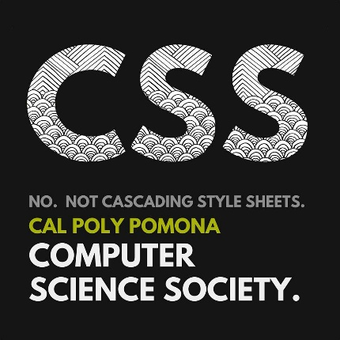

**About:** CSS is a place for students with interests in technology as it pertains to software to meet up and learn more about the field. Students learn from other like-minded students and from the many visiting guest speakers on topics that are current and relevant to the industry. Topics often include software development, programming languages, game development, operating systems and many other topics both big and small.

Functions as a way for students to build real industry software engineering experience, contribute to a moderate scale open source project, and help boost their resume in finding an internship or job. CSS has speakers from all sorts of companies, including Amazon, JPL, Raytheon, Google, and Microsoft, and offer a great way to network with other developers as well as Cal Poly CS students.

**Involvement with Cyber Security:**

* Club intends to touch on good security practices.
* Year-long open source parking application
* Created a REST API where Raspberry Pi’s can update the status of of cars in a parking lot.
  + Issues dealing with security:
  + If anybody can perform the appropriate API request, that can modify traffic data, and corrupt the application state.
  + Some sort of authentication mechanism is required to ensure the the request came from a valid Raspberry Pi.
  + Secret distribution, how to handle secrets in code (not committing them), and how they should be handled at runtime.

**Events:**

* Hold events pertaining to mainly software engineering.
* If cybersecurity is a focus for a certain event or club project, speakers will be brought in to address specific security aspects.

**Links:**

* <https://cpp-css.github.io/>
* <https://github.com/cpp-css>
* <https://www.youtube.com/channel/UC8sXz4RNrixxpLXBI56_jGw>

**3.3.2 MISSA: Management Information Systems Student Association**

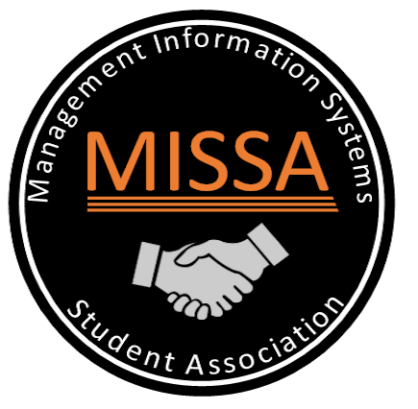

**About:** The Management Information Systems Student Association (MISSA) is a student-run organization based in Computer Information Systems to bring together students and business professionals. MISSA aims to expose students to various fields in Information Technology (IT), including cyber security, through events, workshops, and gatherings. Students are given countless opportunities to learn from other students, faculty, and professionals in the industry. Unlike other clubs in the CIS department, MISSA does not focus on a specific technical field but rather focuses on the business and management aspect of the IT industry. Their main goal is to “provide guidance and opportunities to students who are looking to prepare for a career in the IT industry, but are unsure how to begin.” Covering topics such as resume building, interview skills, and soft skills, MISSA hopes to guide their members towards a successful future.

**Role in Cybersecurity:** While MISSA does not necessarily focus in cybersecurity, their members consist of students from all backgrounds, including cybersecurity. Students in MISSA are encouraged to improve their management and networking skills to effectively communicate with other professionals.

**Events:**

Information Technology Competition (ITC)

* Largest MISSA annual event/competition
* Includes forensics, IT tech, web development, and are adding cybersecurity in future events
* Judges write cases and the students or participants provide solutions
* Bring out colleges and show employers talents in solving real-world cases

**Links:**

<http://www.calpolymissa.org/>

<https://www.facebook.com/cppmissa/?fref=nf>

**Contact:**

eboard@calpolymissa.org

**3.3.3 IWDSA: Interactive Web Development Student Association**



**About**: The Interactive Web Development Student Association (IWDSA) is a student-run organization located on campus at Cal Poly Pomona, formed in 1997  
  
IWDSA consists of students and faculty interested in sharing knowledge, technology, and creativity to foster the learning and support of Interactive Web Development. With this philosophy as the backbone that drives the club forward, let's get together and make it an exciting school year at Cal Poly Pomona in this exciting field.

Interactive Web Development Student Association (IWDSA) is an officially recognized Computer Information Systems student club open to all majors interested in learning about web development and developing their skills and abilities through active involvement in organization events and activities.

**Role in Cybersecurity:** IWDSA doesn’t focus in cybersecurity but goes deep in web development. Their workshops still have topics that are related to cybersecurity such as web vulnerability. Student in IWDSA are encouraged to improve their coding skills to build up their web development career.

**Events:**

* Collaborative Research Projects
* Hands-on Workshops
* Seminars
* Competitions

**Links**:

<https://www.facebook.com/cppmissa/?fref=nf>

**Contact:**

[eboard@calpolymissa.org](mailto:eboard@calpolymissa.org)

**3.3.4 IEEE: Institute of Electrical and Electronics Engineers**



**About:** As the student chapter of the national organization, the Institute of Electrical and Electronics Engineers Cal Poly Pomona student chapter shares IEEE's core purpose to foster technological innovation and excellence for the benefit of humanity.

The Institute of Electrical and Electronics Engineers Cal Poly Pomona student chapter exists for the betterment of California State Polytechnic University, Pomona and its students. With an emphasis on Electrical and Computer Engineering, we focus on the technical, professional, and individual development of all of our student engineers and non-engineers alike. We share IEEE's vision of being essential to the global technical community and to technical professionals everywhere, and being universally recognized for the contributions of technology and of technical professionals in improving global conditions.

* Industry tours to major companies, such as Boeing, Northrop Grumman, and Western Digital.
* Hands-on technical workshops, including our most popular quarterly soldering tutorial.
* Informational presentations by various companies that include, but are not limited to, Raytheon, Thales, and Panasonic Avionics Corporation.
* Endless networking and professional communication opportunities with industry professionals and alumni working in industry.
* Fun, engaging, social activities for our current and graduated student members to expand professional and social networks.
* Professional development opportunities through locally hosted conferences, such as SPAx (Student Professional Awareness Experience).

## **Events:**

* Internet of Things (IoT)
* Micromouse Project
* Hackathons
* Student Professional Aswareness Experience (SPAX)
* Consumer Electronics Show (CES)
* Company Tours
* Workshops
* Quarterly Soldering Tutorials
* Mentorship Program

**Links**:

<http://www.cppieee.org/>

https://www.facebook.com/cppieee/

**Contact**: contact@cppieee.org

**3.3.5 FAST: Forensics and Security Technology**



**About:** [Forensics and Security Technology (FAST)](http://www.cppfast.org/) is the official Cal Poly Pomona student chapter of the High Technology Crime Investigation Association. FAST aims to expose students to Digital Forensics, Cyber Crime, and Cyber Security through knowledge development, hands-on workshops, and real world experiences.  Visit [www.cppfast.org](http://www.cppfast.org/) for more information including meeting times and locations.

Our members have hands on forensic experience, penetration testing, and exploit development.  Many of our members are seen doing internships with the NSA, FBI, NASA, DOD, Google, Amazon, and top companies.  As the president, I just completed a 7-month co-op internship with NASA and am going into the NSA next summer.  As an organization, I try to expose CIS/CS students to additional lab experience and expose them to concepts that can be applied to training on the job.

## **Specializations:**

* Digital forensics
* Incident Response
* Penetration Testing
* Exploit Development

**Links**:

<http://www.cppfast.org/>

https://www.facebook.com/cppfast/

**Contact**: fast@cpp.edu

**3.3.5 SWIFT: Students With Interests in Future Technology**



**About:** We are Students with an Interest in the Future of Technology, we are the premier information technology and security organization at Cal Poly Pomona. We aim to inspire and create a generation of students who are aware and capable of dealing with the dynamic landscape of information security, cyber security, and information technology. Together we can build a secure future through training, experience, and education. Let's work together to create and learn something new. Don't just take our word for it. Whether you are an industry professional or a curious student, take a look at our previous events. While you're at it, come to one of our unique workshops, trainings, or conferences and become SWIFT.

For over 20 years, SWIFT has been dedicated to propelling students into the future by introducing them to cyber security, forensics, network security, and systems administration. Now it is your chance. Join SWIFT in pushing the boundaries of technologies through research, hands on learning, workshops, and trainings, and competitions.

**Events:**

* Tech Symposium
* Layer One Conference
* Frag Night
* Hack Poly
* DefCon

**Links**:

<http://www.calpolyswift.org>

<https://www.facebook.com/calpolySWIFT/>

https://www.twitter.com/calpolySWIFT

**Contact**: swift@cpp.edu

**3.4 Researching and Creating Wireframe**

To make sure we were approaching this project in the right direction, we decided to conduct interviews with professors to gain a better understanding of what their vision for the site should look like.

We decided to meet with Dr. Gregory Carlton, Director of Computer Forensics at Cal Poly Pomona. It was important to have a tangible and visual representation to demonstrate to Dr. Carlton an idea for the direction discussed for the website. We created a basic wireframe mockup of the site using various tool from demonstrative purposes.

Our team did extensive research on what form of website layout would be best suited for the project requested by the client. After lots of discussion, we concluded on a modern layout with a large header image and four informational sections on the bottom. The client expressed a desire to have the site go hand-in-hand with “The Center for Applied Business Information Systems” website, also known as the Mitch C. Hill. site. The site has a clean, modern layout with an easy to navigate user experience. The site is mostly white with gray text and light hints of green. We chose not to stray away from those colors and made our color scheme, mostly white and grays to complement one another.

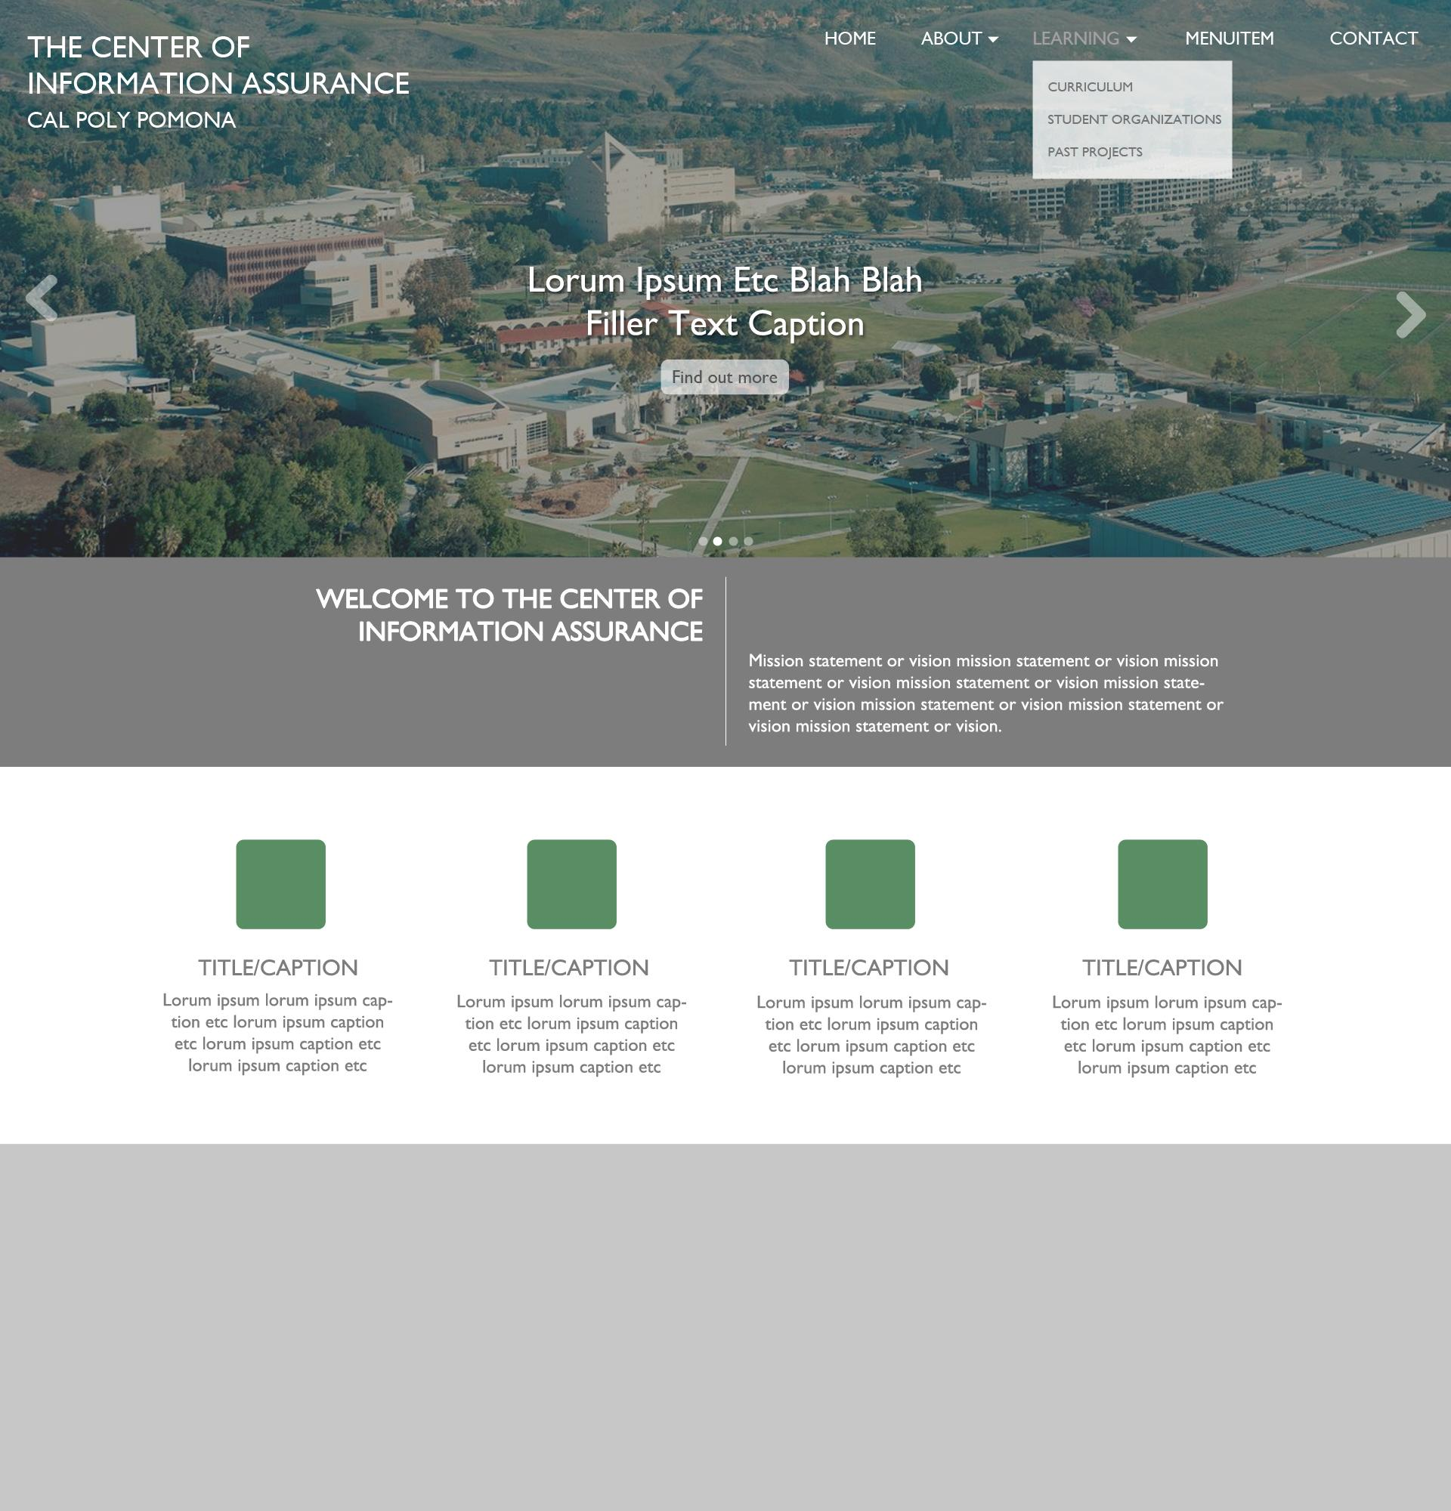

***Figure 7:*** *Wireframe*

**3.5 Style and Design**

In creating a cohesive website, we agreed to create icons using Adobe Photoshop to be displayed on the homepage. Those icons are: cyber security, goals and objectives, research, and projects. The site will consist of Cal Poly Pomona’s school colors in a clean and modern fashion throughout.

   

***Figure******8:*** *Website Icons*

These are some of the banner images used during our early iteration of the website. These banner images will be displayed under the navigation bar and above all the content. The first two images were selected as a representation of the university and the campus. The last images were chosen because it had simplistic elements that incorporated binary graphics.

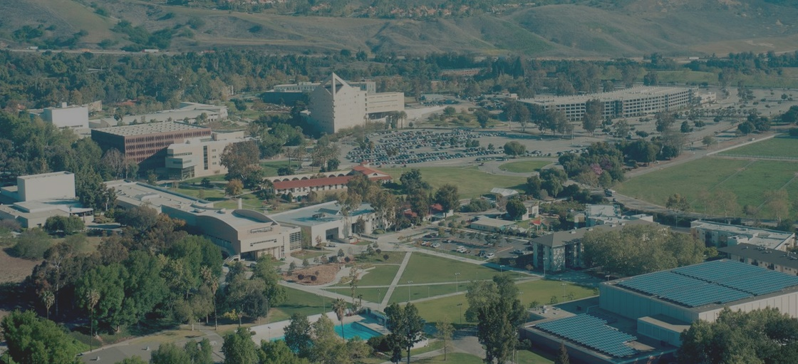

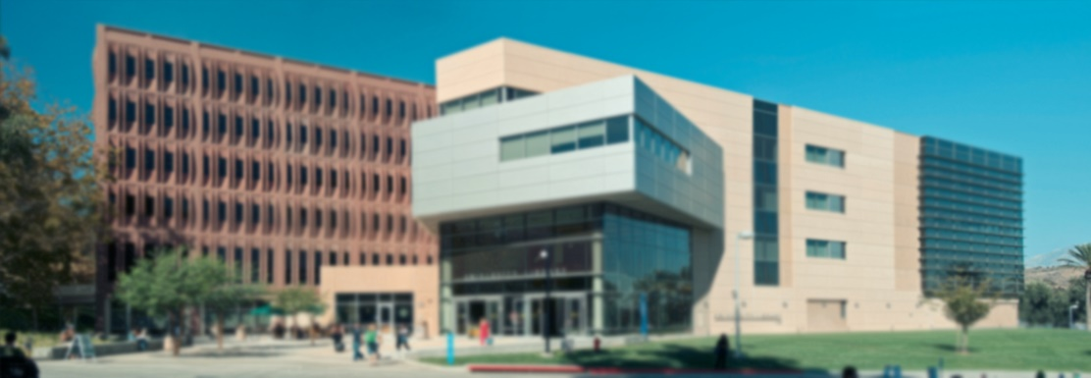



***Figure 9****: Banner Images*

We wanted the site to be responsive to the size of the window as well as adapt to mobile devices. When viewing the site from a mobile device, our developers had the navigation bar collapse into a hamburger menu for easy access to the navigation. The navigation bar is also responsive according to how the windows is resized.

|  |  |
| --- | --- |
| **Color Palette:**  **#598e62**  **#7d7d7d**  **#a9a9a9** | **Font:** |
|  |  |

***Figure 10:*** *Style References*

**4. Challenges and Obstacles**

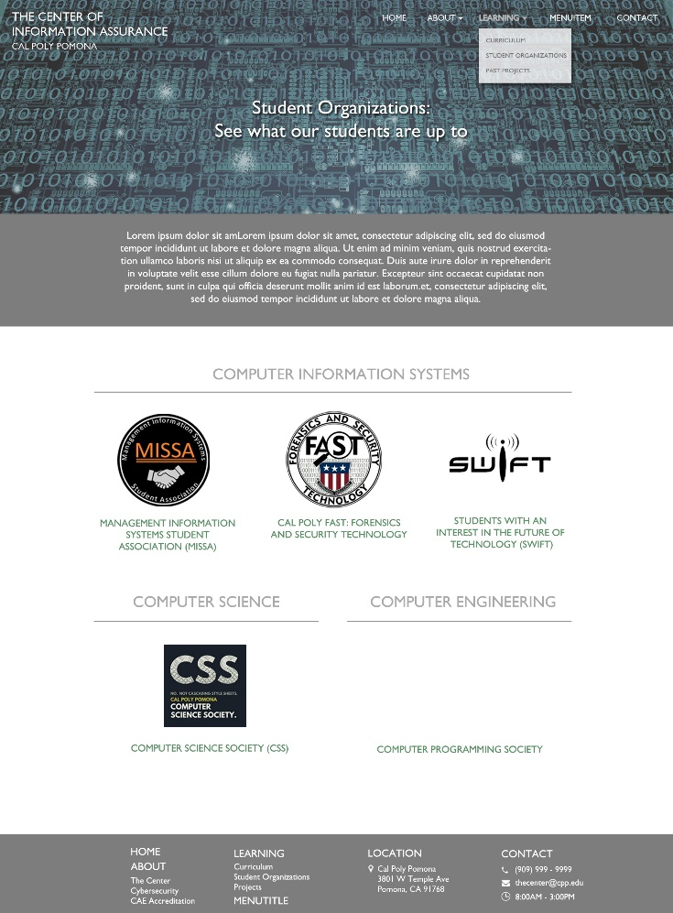Designing the wireframe was challenging initially because we **did not have the original site available** to use as a reference. The current site is down, so we had to find an archived version that was saved online using Internet Archive: WayBack Machineas a tool to view it. One of the concerns the client expressed was to attempt to utilize Cal Poly Pomona’s school colors, without it being too brash as seen on the current site. Midway through the completion of the project, the original site became available to view. Since becoming available, we had a lot more content to reference and overall site structure to go off of. The burden of trying to gather content was made easier as the original site became available.

**Figure 11:** Student Organizations Page

Another problem we had in our process of **collecting content and information** was that we were not successful getting responses from the clubs and professors. We had wanted to collect the information directly from the organizations to personalize their section in the website exactly to their specifications. Since we were not able to obtain a response from half our contacts, we decided to research the organizations and provide information on their behalf as best as we could.

We also wanted to make the website responsible to different window aspect ratios as well as mobile compatible, we designed the site to be dynamic. Some of the problems we faced when implementing this feature was that the layouts and image aspect ratios would be skewed and begin overlapping. This gave us trouble as we wanted to ensure that the site maintained as user-friendly as possible at all times.

**Hosting** the site also became a problem near the end of the project cycle. Our original plan involved having the website hosted at the Student Data Center on campus using the domain CPPCenterForIA.com. Some of the problems we encountered was that we needed the computer science department to approve the hosting. Due to the length of time needed to receive approval, hosting was not in the scope of the project. Resolution: Dr. Husain agreed to make himself available to work with in the future to receive CS department approval in the future.

**5. Time Distribution**

**Client Meeting 1**

**Date/Time:** October 4th, 2016 - 11:00AM to 12:00PM

**Meeting Location:** Client Office, 164-3013

**Purpose**: Establish overall objectives for the direction of the site redesign.

Notable points from the meeting:

* Create a central location to represent information assurance at Cal Poly Pomona
* The client expressed an interest to have the site go hand-in-hand with the “Center for Applied Business Technology” website, also known as the Mitchell C. Hill website.
* Make the site cross interdisciplinary. The site should not focus solely on computer information systems, but should include other departments (i.e. computer science and electrical engineering)
* Have a location to showcase all the clubs and all their research, events, and accomplishments.

**Client Meeting 2**

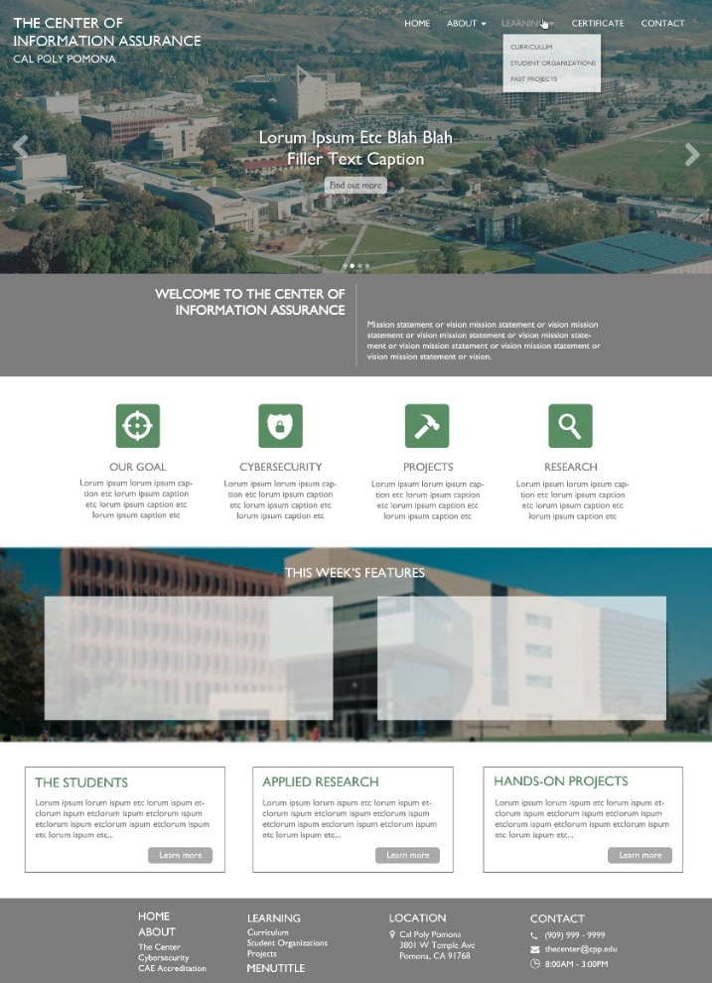**Date/Time:** October 20th, 2016 - 12:00PM to 1:00PM

**Meeting Location:** Client Office, 164-3013

**Purpose**: Discuss the progress on the website and what content should occupy the pages. During this meeting, we had a mockup of the homepage setup with a general layout of the site. Here were some notable topics from the meeting:

* Discussion as to what the main navigation bar should be and what the sub categories will be.
* Desire to have a curriculum section on the site and explain how they will align with student projects.
* Including a section on the site for competition information (i.e. upcoming events, why they are important, discuss different types of events, etc.)

**Figure 12:** Mockup

* Credentials for the website and where they should be obtained from.
* New alternatives for the site name and abandoning the current name, “The Center for Information Assurance”.
* How we should go about obtaining content for the website.

**Meeting with Dr. Husain**

**Date/Time:** November 28th, 2016 - 12:00PM to 1:00PM

**Meeting Location:** Dr. Husain’s Office

**Purpose**: Discuss the hosting of the website.

Notable Points:

* Approved of site design and layout.
* Hosting issues lie in getting department approvals before letting the site go public.
* Content must be approved by department due to their need to see something that represents them.
* Is open to working with whoever takes control of the site in order to get it hosted eventually.

**5.1 GANTT Chart**

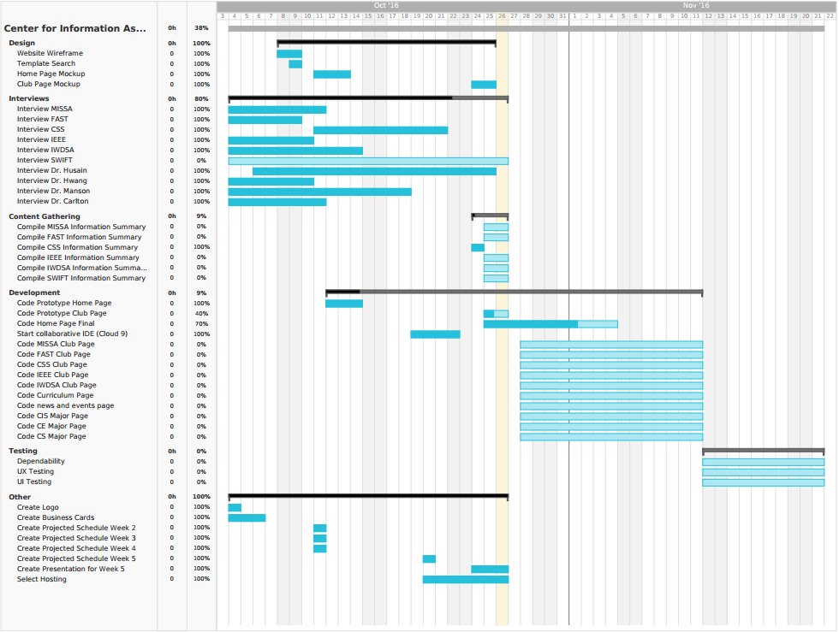

***Figure 13****: GANTT Chart*

After concluding the client briefing and learning all the requirements, we wanted to create a strategic plan to complete the assignment by the deadline. One of the challenged we faced was not having access to the previous and/or current Center for Information Assurance website. As a result, we had nothing to reference to and no content to put on our new redesigned version. We decided to focus our attention for the first two weeks to gathering content by conducting interviews with clubs, organizations, and faculty.

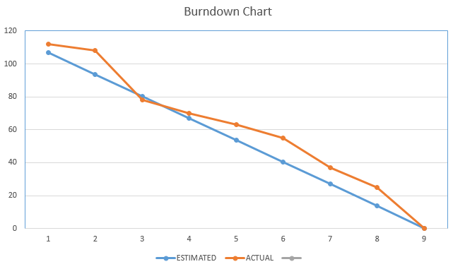

***Figure 14****: Burndown Chart*

This task took longer than anticipated due to non-responses from our recipients, so we gathered the remaining content using information available online. During the time when we were waiting for responses and meetings, we had discussed whether to use a template or build one from scratch. Due to time constraints, we decided to use a template as a starting point. We built a wireframe with filler text so that we can present to our client Dr. Ronald E. Pike as well as Dr. Manson for critique and suggestions.

Since we did not have enough content initially after of meeting with our client, we decided to focus all our time and effort into collecting content rather than beginning development. We had enough developers to feel confident that we would be able to offset the extra time that we are performing research and content gathering. The GANTT chart illustrates how we dedicated the first 2 weeks in our research phase. It had taken longer than anticipated which cut into our development schedule. We had discussed whether we wanted to create the project from scratch or find a template to build off of. We choose the latter after realizing how much time we lost in the first few weeks. Our developers were able to work fast and managed to get our project back on schedule by week 4. We anticipate that the project gets completed on schedule.

**6. UX Testing**

**Testing Methodology**

The testing process will involve user testers to perform a set of five tasks on the website. Each user will take a demographic survey before starting the test. Whoever is moderating the test will follow a general script to keep consistency and to let the user know why and what we are testing. While the user is performing each task, the moderator will time each task and record notable comments each user says.

**Demographic Survey**

1. What is your age?

[13-17]       [18-25]         [26+]

2. How would you describe your occupation?

[University Student]      [High School Student]       [Faculty]       [Other]

3.How knowledgeable are you about cyber security?

[1 - None]  [2]   [3]   [4]  [5 - Very]

4.Are you involved with cyber security?

[Yes]  [No]

**Moderator Script**

Introduction - Introduce self and purpose of the testing.

Tell user what we are doing: What you will be participating in is a user experience test for a new website developed for the Center for Information Assurance at Cal Poly Pomona. Your participation will help in improving the design and usability by allowing us observe how you navigate the website.

Specify what is required of the user: While you are performing the given tasks, please speak aloud throughout the entire process. We want to hear your thoughts on every aspect of each task. Do not afraid to be honest, such as when you are having trouble completing a task. The purpose of this test is to figure out how we can improve on it.

Conclude: Any feedback and criticism is greatly appreciated, so feel free to continue browsing once all tasks are completed.

**Tasks**

Task 1: Learn about the Computer Science department’s curriculum.

Task 2: Figure out where the Cyber Security and Awareness Fair is located.

Task 3: Visit the faculty page and read about Dr. Ronald Pike.

Task 4: Find the club page for CSS.

Task 5: Find the mission statement of the Center for Information Assurance.

**Demographic Survey Results**

|  |  |  |  |  |
| --- | --- | --- | --- | --- |
| **User** | **Q1** | **Q2** | **Q3** | **Q4** |
| **User1** | 18-25 | University Student | 4 | Yes |
| **User2** | 26+ | Faculty | 18.0s | Yes |
| **User3** | 18-25 | University Student | 2 | No |
| **User4** | 26+ | Other | 5 | Yes |
| **User5** | 13-17 | High School Student | 1 | No |

**Task Results**

|  |  |  |  |  |  |  |
| --- | --- | --- | --- | --- | --- | --- |
| **User** | **Task 1** | **Task 2** | **Task 3** | **Task 4** | **Task 5** | **Comments** |
| **User1** | 10.2s | 11.0s | 9.5s | 12.7s | 5.6s | ·         The tabs are nice  ·         The content is very well organized |
| **User2** | 12.95s | 13.6s | 15.0s | 19.68s | 9.4s | ·         Spacing in the club page is a bit weird |
| **User3** | 15.11s | 14.35s | 11.45s | 16.26s | 8.5s | ·         Love the home page |
| **User4** | 13.2s | 10.12s | 13.1s | 14.43s | 9.3s | ·         I like the photo slider  ·         Very clean |
| **User5** | 9.4s | 8.72s | 8.9s | 10.21s | 6.9s | ·         The effects on the home page add a nice touch  ·         The banner images load up weirdly |

**7. Measures of Success**

It is important that we hit the marks that satisfy the client’s needs in the completion of the project. We will be measuring success with 5 forms of criteria: Site functionality, the organizations agree on design, considerable content on the site, UX design testing meets standards, and successfully completing project on schedule.

|  |  |  |
| --- | --- | --- |
| **Metrics** | **Description** | **Score 1-5** |
| 1 | Site functions and hosted successfully | 4 |
| 2 | All organizations we work with agree on design | 5 |
| 3 | Considerable content on the site | 4.5 |
| 4 | UX design testing met standards | 5 |
| 5 | Project was completed on schedule | 5 |
| **TOTAL SCORE** | | 23.5 / 25 |

The site was functional, and works successfully. However, we were not able to get the website hosted within our estimated timespan. The hosting issue is expected to be resolved in the future with Dr. Hussain. The content on the site was gathered through our team members interviewing and meeting with various people in different clubs and organizations. Unfortunately, we were not provided with enough content to fill certain pages (i.e. projects page, CSS page).

**8. Project Proposal**

Project will initially be presented as a wireframe with a prototype build to present to our client. Upon completion, the product will be successfully hosted on an external server and fully functional on any web accessible device.

**9. Project README for Next Group**

README

* All the html pages have been written in HTML5 and we use CSS3 for our stylesheets
* The index.html, about.html, contact.html, curriculum.html, projects.html, scholarships.html just ruse the layout.css file and the layout is coded using FLEX-BOX
* The other pages use style.css (this is due we had two developers so we used two different stylesheets)
* The other pages not listed above are also using bootstrap.

**Suggestions you can add to the project:**

* Organization of the code
* Combine the layout.css and style.css
* Use bootstrap for the whole site or just use flexbox for the whole site for clarity.
  + Bootstrap overrides some CSS so its hard to change some of its styles
* Missing content
  + Club information

**Libraries used:**

* Fontawesome ([www.fontawesome.io](http://www.fontawesome.io/))
  + Icons
* Hover.css (<https://github.com/IanLunn/Hover>)
  + Hover animations
* AOS (<https://michalsnik.github.io/aos/>)
  + Animation on scroll
* Hamburgers (<https://jonsuh.com/hamburgers/>)
  + Hamburger menu
* Slick carousel (<http://kenwheeler.github.io/slick/>)
  + For carousel

**Tutorials**

* Flexbox:
  + <https://www.youtube.com/watch?v=G7EIAgfkhmg>